MALDÍV-szigetek : KURAMATHI ISLAND RESORT 4 csillagos
Déli-Rasdhoo-atoll, 900 m x 200m, housereef: 30-50 m hidroplántranszfer 30 perc,
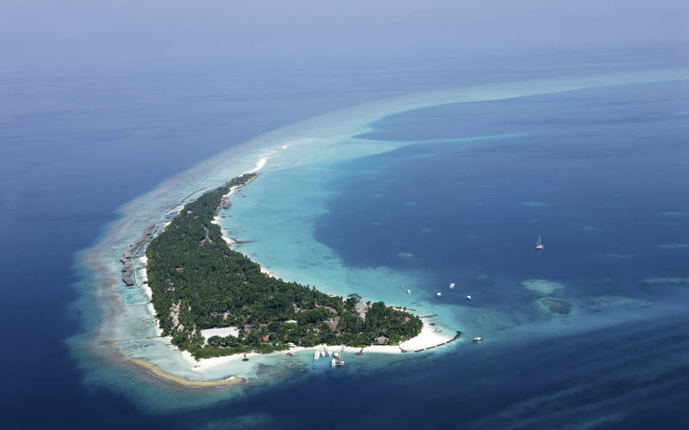
Ez a 290 lakóegységes minőségi szolgáltatást nyújtó sziget 3 főétteremmel rendelkezik valamint 6 Á LA CARTE étteremmel. Napközben és esténként 6 különböző bárban lehet különféle italokat inni. 2 úszómedence, teniszpálya, fittness terem, asztali tenisz, szauna, jacuzzi, spa- masszázs, búvár központ, külön gyermek klub, butikok. A sziget dús trópusi növényzete, és egy gyönyörű, nyugati irányban elhúzódó, közel 100 m –s homok pad teszi felejthetetlenné az itt töltött üdülést.
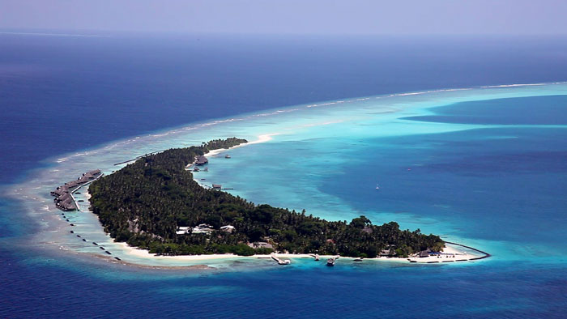
Kuramathi szigete büszkén viseli a 2012- ben kapott TRIP ADVISORS díjat!
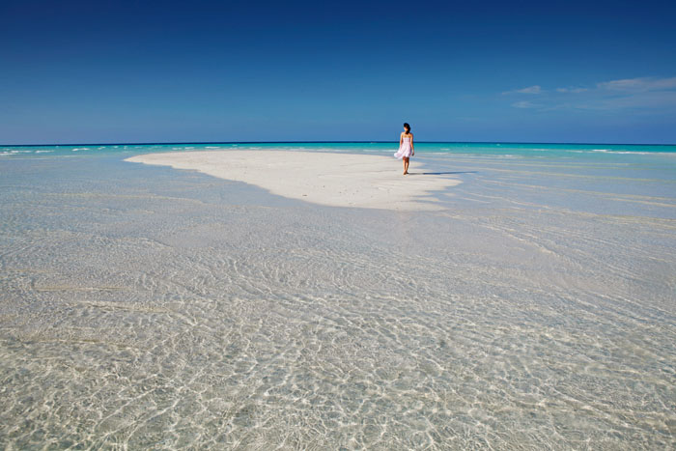
Guests travelling by seaplane to Kuramathi Island Resort will also have use of a dedicated private lounge at Malé airport, ensuring a relaxing start to your holiday.
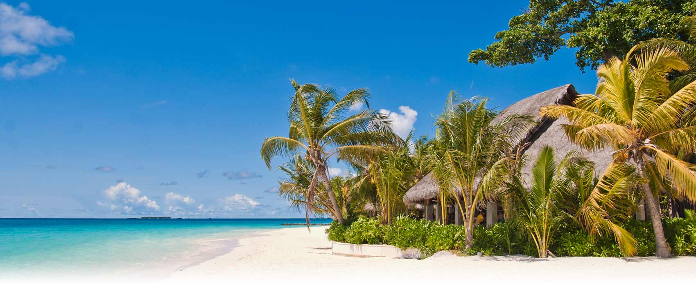
Mind a 290 lakrész a szigeten és a vízre épültek is fel vannak szerelve légkondicionálóval, külön ventillátorral, nagy méretű francia ággyal, minibárral, telefonnal, lapos képernyős Tv –vel, DVDV lejátszóval, iPod dokkolóval, terasszal

KERTI Villa (45m²) are simply designed.
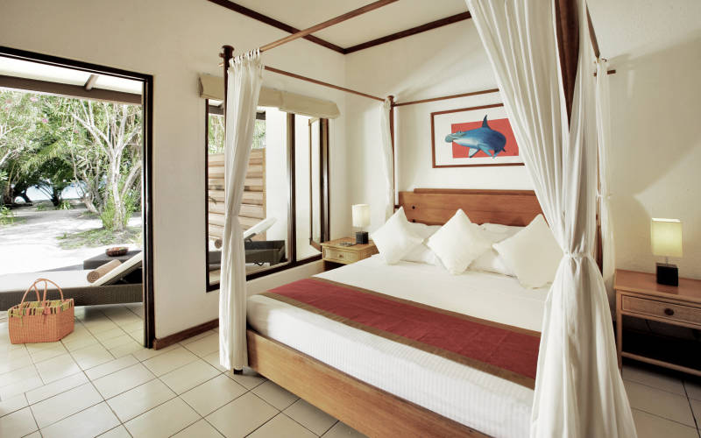
Beach Villa (70m²)
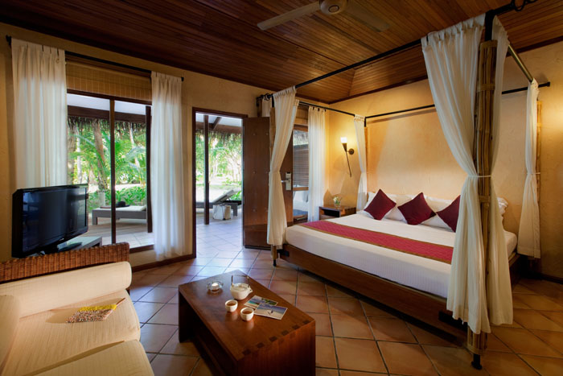

Deluxe Beach Villas
(51m²) have a bath and are a short stroll from the sand bank.
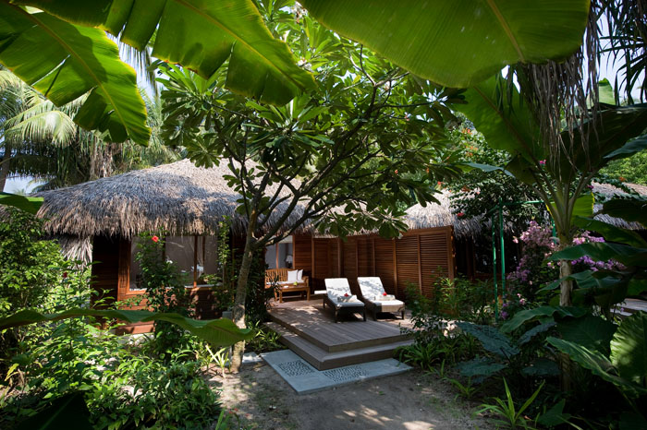
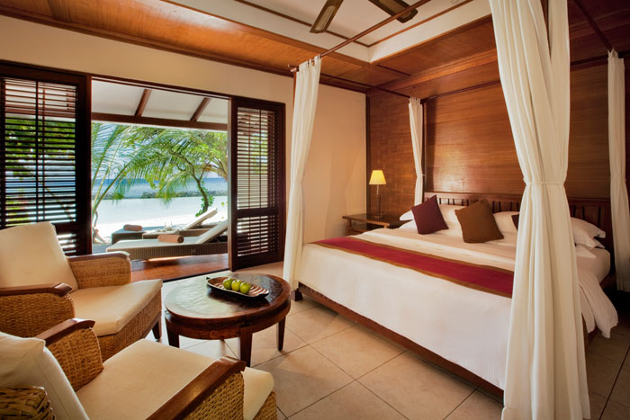

Beach Villas with Jacuzzi (90m²) enjoy a garden bathroom and deck.
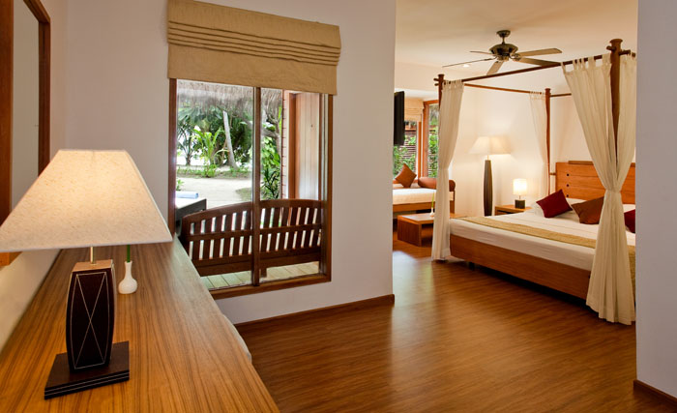
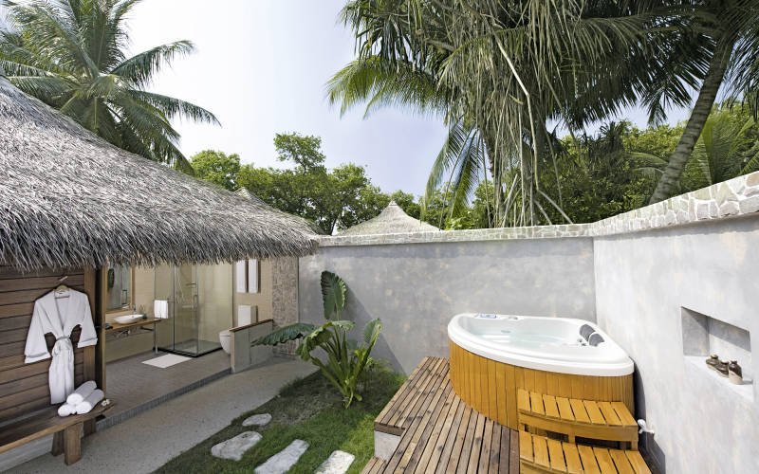

Superior Beach Villas with Jacuzzi (90m²) are round in shape and contemporary.
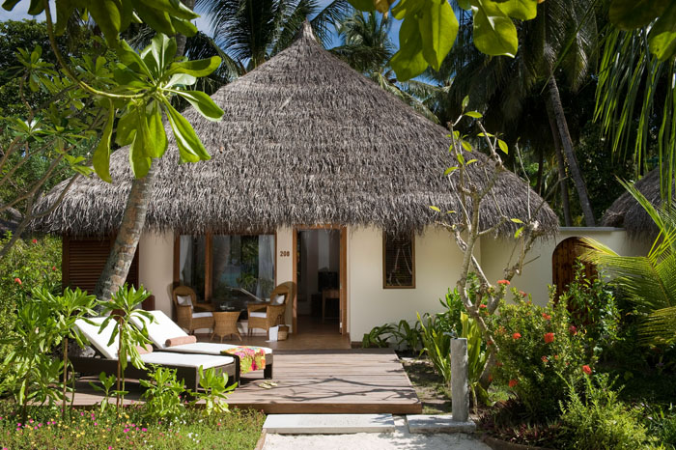

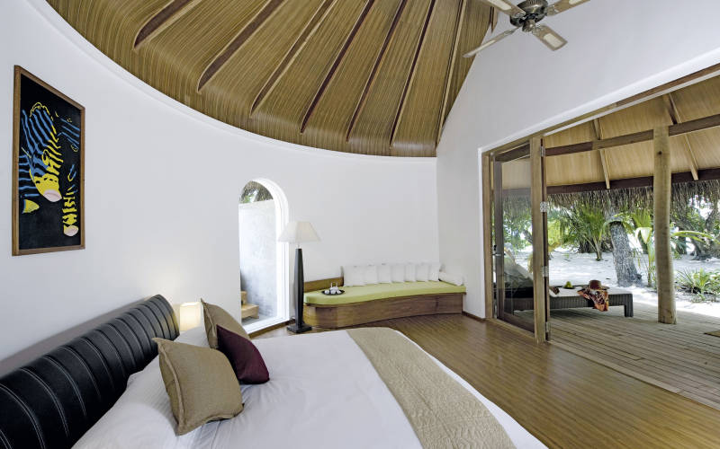
Deluxe Beach Villas with Jacuzzi (95m²) face the lagoon with four poster beds, bath, outdoor rainfall shower and Jacuzzi.
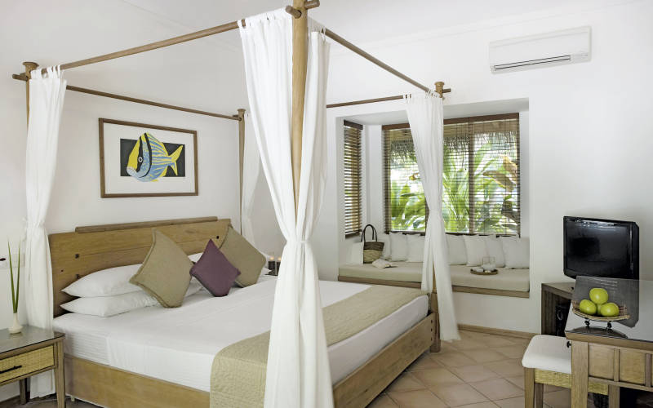
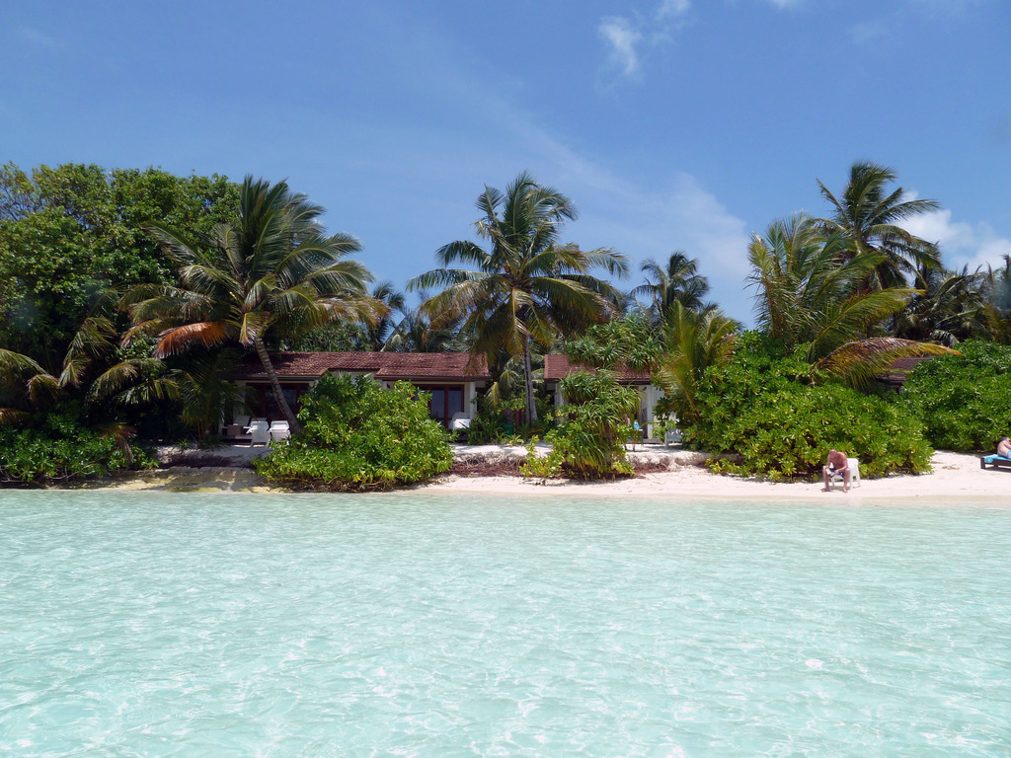
Water Villas (52m²) are on stilts with a deck and steps down to the sea.
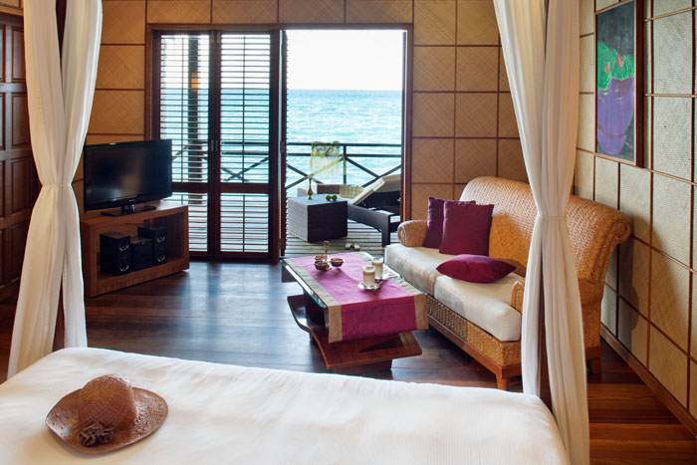
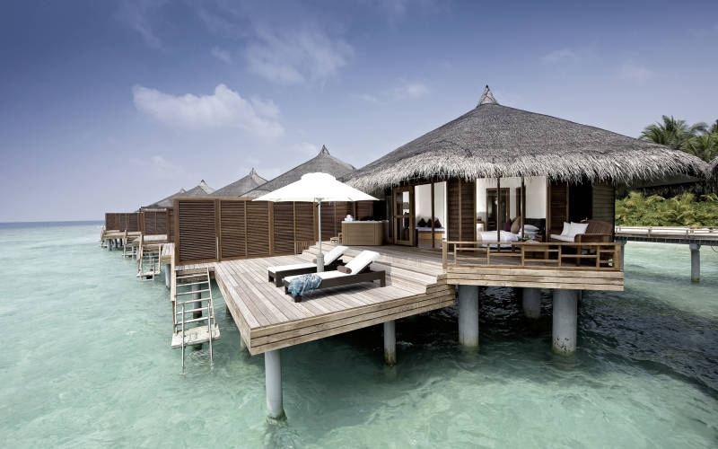

Water Villas with Jacuzzi
(90m²) also have a large two-tiered sundeck and outdoor Jacuzzi.
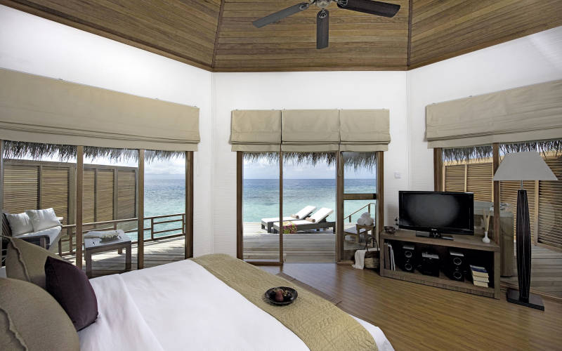
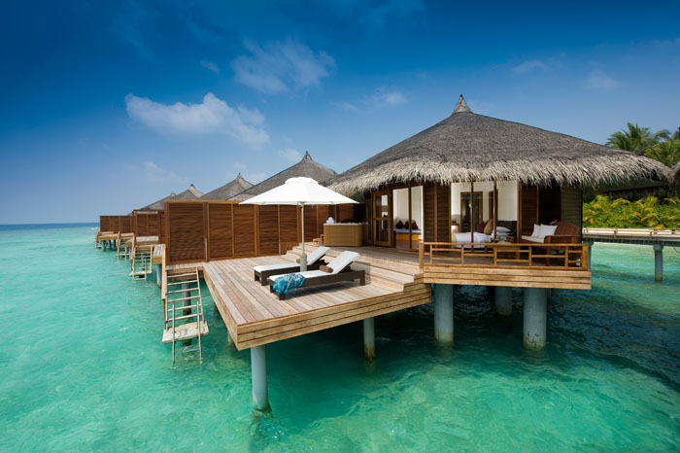

Honeymoon Pool Villas (310m²) have a ten metre lap pool.

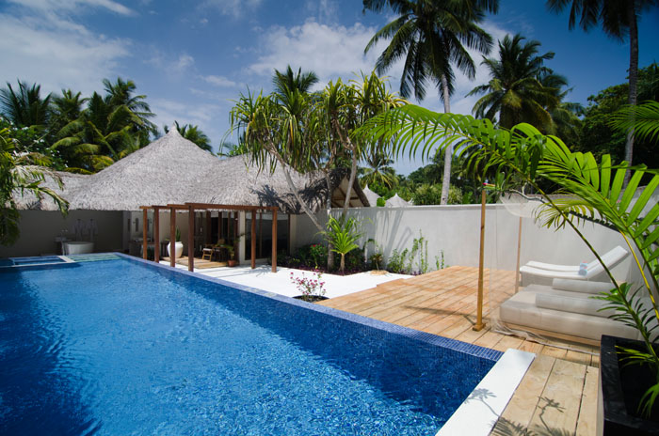

Children's club
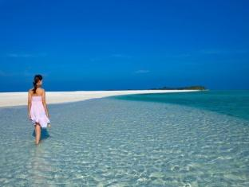
Bageecha, open from 8.30am-10pm every day, offers a wide range of outdoor activities organised for kids of 3-12 years.
Daytime activities include:
• Night walks
• Body and face painting
• Marshmallow grilling on the beach
• Guided snorkelling
• Beach games
• Marine life education.
Evening activities include:
• Movie nights
• Mini discos and game nights.
The club also celebrates special occasions and festivals such as Easter, Halloween, Christmas with extra fun activities.

All Inclusive
ALL INCLUSIVE OPTION
• All meals in designated main restaurant, all drinks (soft, mineral water, selected spirits, house wines, beer)
• High tea at Island Coffee Shop and Dhoni Bar (3-5pm)
• Windsurfing (tuition not included)
• Snorkelling equipment
• 1 sunset cruise and 1 local island visit per stay.
SELECT ALL INCLUSIVE OPTION
• A main restaurant is allocated to you with the other restaurants also available by reservation (excludes private dining and lobster dishes)
• A selection of bottled wines (served with meals).

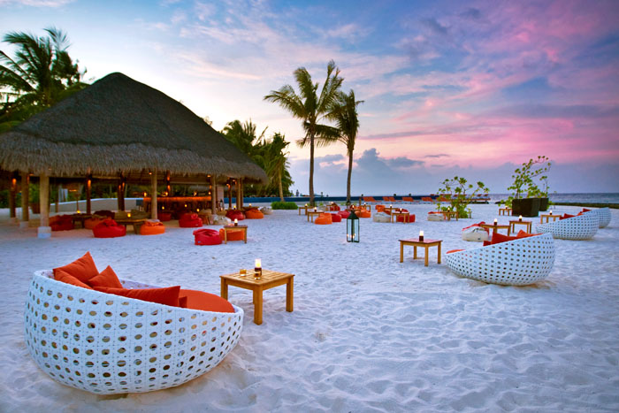

Weddings Island Renewal of Vows
Includes homemade chocolates and sparkling wines in room on arrival, tropical bouquet for the bride and buttonhole for the groom, decorated venue with podium, palm arches with tropical decorations, renewal of vow party including master of ceremony, bridesmaid, local drummers, celebration cake and sparkling wine, finger food and house wine for the invitees, 24 photos and wedding album, framed photo, certificate and traditional gift from the hotel, a five-course candlelit dinner on the beach, served with sparkling wine, local sarong and t-shirt for bride and groom and a sparkling wine in-villa breakfast in bed, the morning after the ceremony. The ceremony will take place with the Indian Ocean as a stunning backdrop.
From £1272 per couple

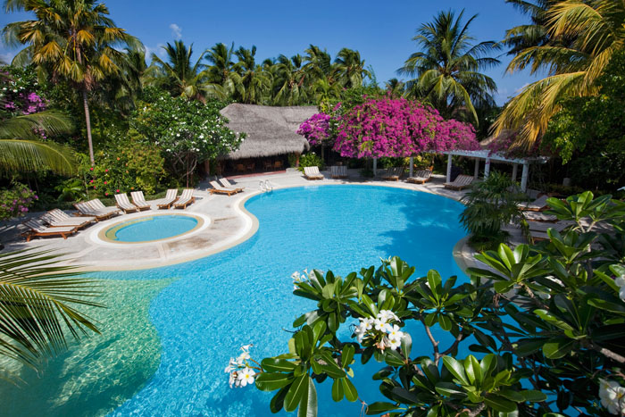

Spa & wellnessThe facilities at the spa include two overwater treatment rooms and seven beach treatment rooms and a dedicated herbal bath room.

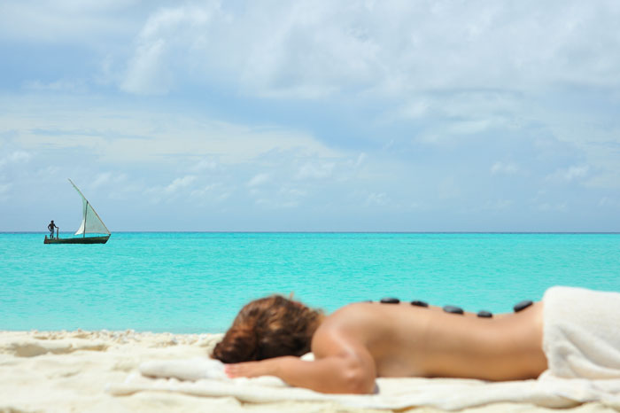

BÚVÁROKNAK : Rasdhoo Divers operates two dive schools on the island (both PADI Gold Palm/SSI facility/International Aquanautic Club). The multi-lingual team offers an excellent diving experience for both advanced divers and beginners.
Rasdhoo Atoll features more than 20 exciting dive sites reachable in just 5 to 45 minutes on purpose-built 15m diving dhonis (Maldivian boats), including world famous Hammerhead Shark Point, which is only 8 minutes away.
As Rasdhoo Atoll is comparatively small, boat trips are relatively short and always dive on the outside reef which means there is deep water (160m+) and this attracts many pelagic species. There are different types of dive sites which vary between channels, walls, reefs, thilas and even a couple of wrecks.
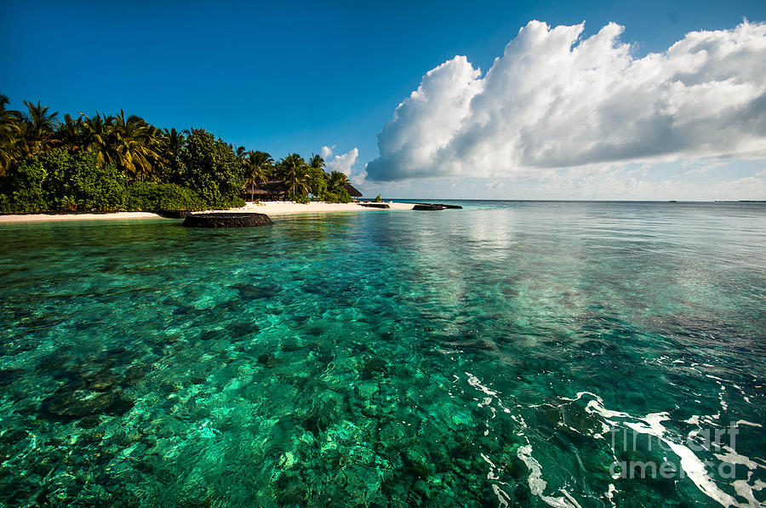
Drift diving with the current along the outside wall of the atoll is usually easy while channel dives can have more current and are more challenging. The fish life in Rasdhoo Atoll is diverse and abundant. You can see many different types of sharks here (and you will see sharks on almost every dive), eagle rays, stingrays, manta rays (November to April), turtles, barracuda, tuna, Napoleons, morays, schools of jacks and trevally, leaf fish and even the occasional whale shark.
Supplement the local sites with half and full day dive trips to nearby North Ari atoll where there are many more spectacular dive sites.
The dive program for certified divers includes early morning Hammerhead Shark Point four times weekly, daily morning and afternoon dives from both dive schools, night dives four times weekly, full day safaris to North Ari Atoll twice weekly and other half day trips to North Ari.
Unguided house reef diving is also available for advanced divers with a minimum of 50 logged dives. A wide range of beginner and advanced diver courses are offered and Kuramathi is a wonderful place to learn to dive. Nitrox (32%) is provided free of charge for nitrox certified divers.
